**User Manuals**

目录

I: Content Introduction 1

About 5G 1

The purpose of designing this WIKI website 2

II: How to edit the WIKI? 2

Home page: 3

Four main pages： 5

5G 5

Radio spectrum simplified 6

Low, mid and high band 5G summarized 7

5G Market 9

III: About our team 10

# I: Content Introduction

## About 5G

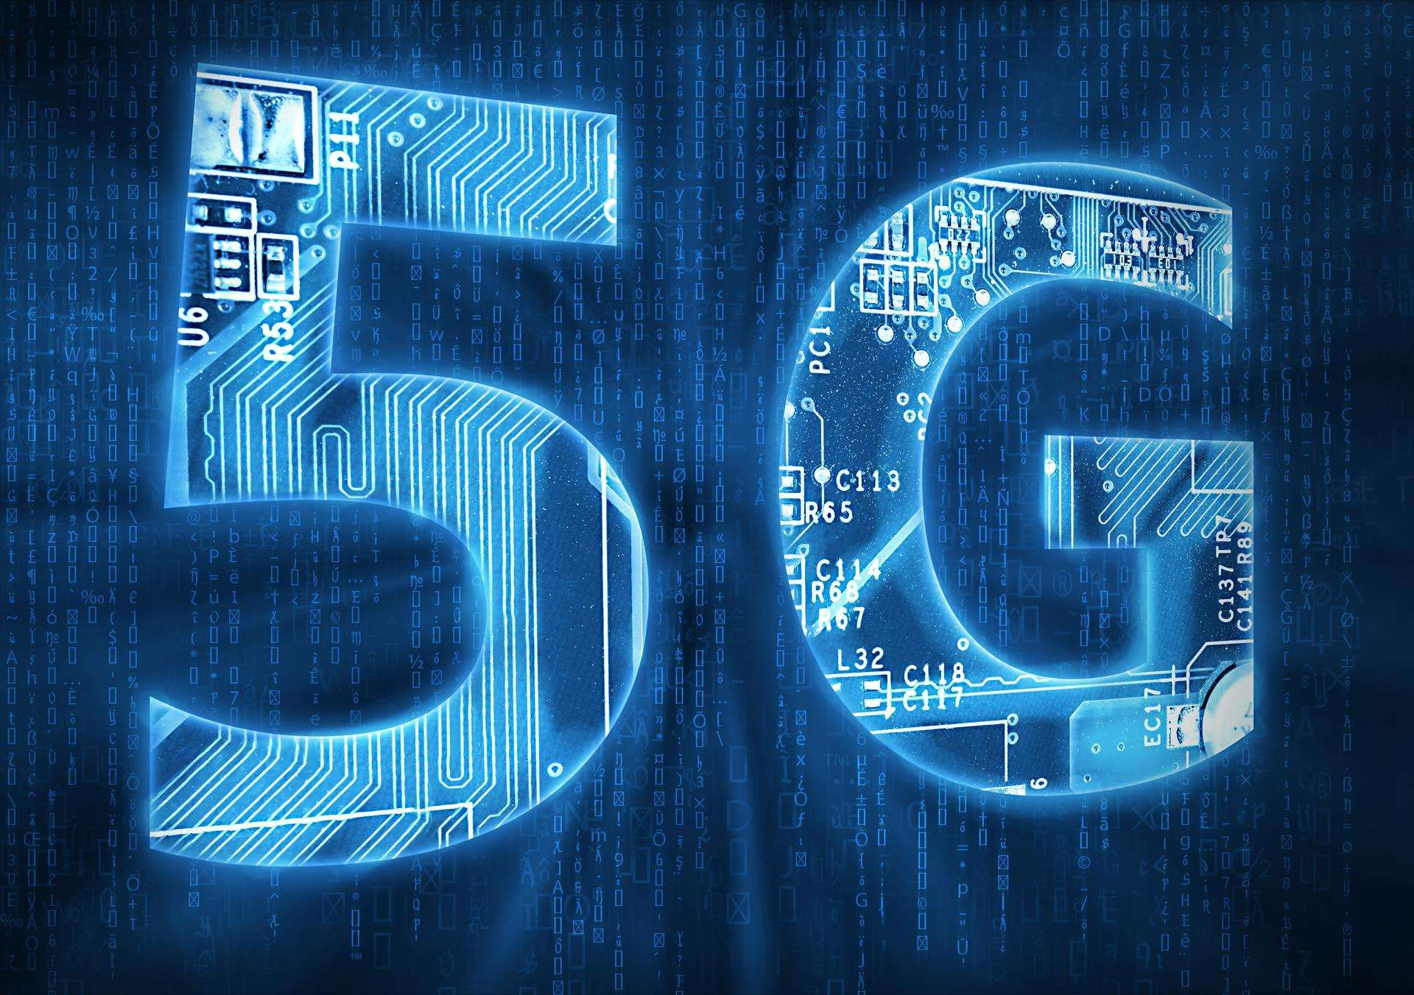

The 5th generation mobile communication technology (5G for short) is a new generation broadband mobile communication technology with the characteristics of high speed, low delay and large connection. 5g communication facilities are the network infrastructure to realize man-machine and object interconnection.

The International Telecommunication Union (ITU) has defined three categories of 5g application scenarios, namely, enhanced mobile broadband (embB), ultra high reliable low delay communication (urllc) and mass machine communication (mmtc). Enhanced mobile broadband (embB) is mainly aimed at the explosive growth of mobile Internet traffic, providing more extreme application experience for mobile Internet users; Ultra high reliability and low time delay communication (urllc) is mainly used in vertical industries with high requirements for time delay and reliability, such as industrial control, telemedicine and automatic driving; Mass machine communication (mmtc) is mainly aimed at smart cities, smart homes, environmental monitoring and other applications that aim at sensing and data acquisition.

## The purpose of designing this WIKI website



# We designed this wiki to solve users' questions about 5G technology, focusing on the popularity of 5G technology.

# II: How to edit the WIKI?

Before learning how to edit WIKI, we hope you can observe the following rules：

1. **Uncivilized language is forbidden in the web page:**

Please communicate with other users in a civilized manner, and don't feel bad because of different opinions.

1. **No advertisement in the website**:

Please visit this website with a learning attitude and do not publicize news irrelevant to the theme of the website.

1. **Spreading false information is prohibited in the website**:

Please visit this website with a strict attitude and ensure the authenticity of any information before publishing it.

1. **Illegal editing formats are prohibited in the website:**

Please edit your information in a serious manner to ensure that your information format is legal

**Next, we will tell you more about the formatting criteria and detailed operation of each page**

Home page:

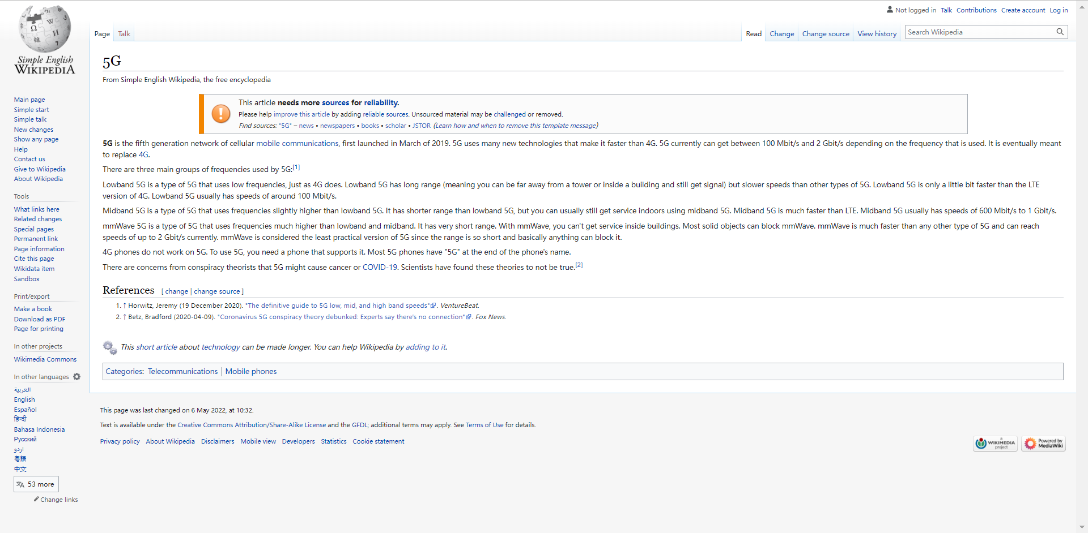

The page shown in the figure above is the home page of this website, from which you can access other related pages.

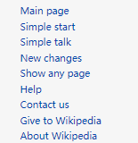

Click the link shown above to jump to the main introduction of 5G. 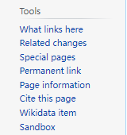

Click the link shown above to jump to the tool page you need. 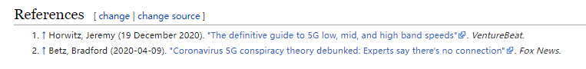

Click the link above to jump to the source file of this website. 

By clicking the button shown above, you can jump to the user manual or log in to the website.

## Four main pages：

### 5G

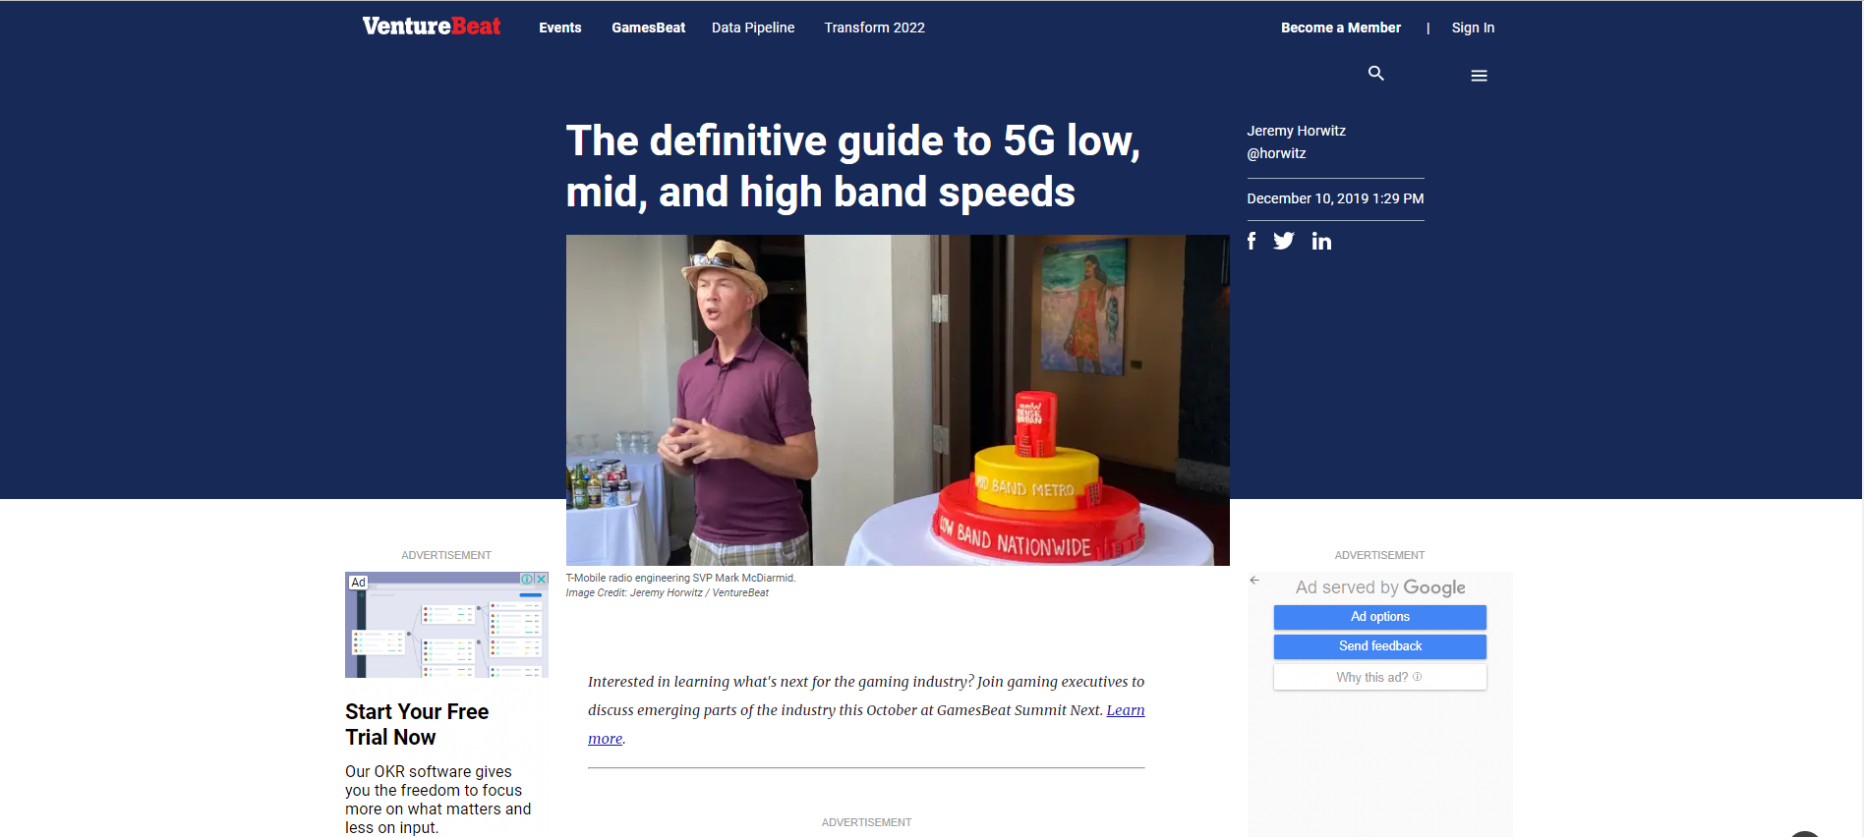

On this page, you can browse the news about Web3.0.



Click here, you can edit the news about Web3.0 with us.



Click here, you can see other users' comments.



Click here, you can add a comment Web3.0.

### Radio spectrum, simplified

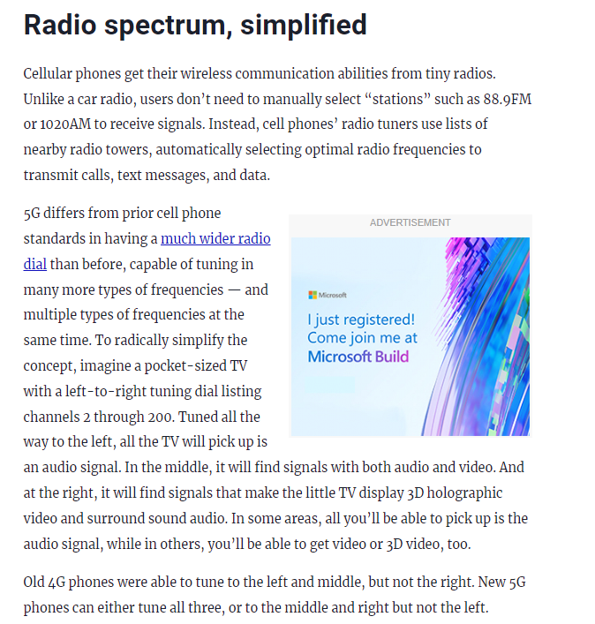

On this page, you can browse the information about the introduction to

radio spectrum.



Click here, you can edit the news about the introduction to radio spectrum with us.



Click here, you can see other users' comments.



Click here, you can add a comment the introduction to radio spectrum with us

## Low, mid, and high band 5G, summarized

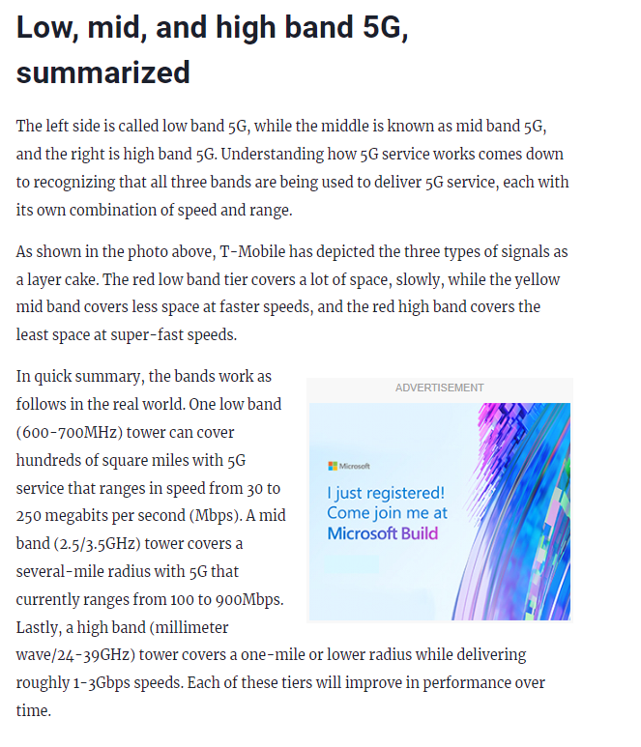

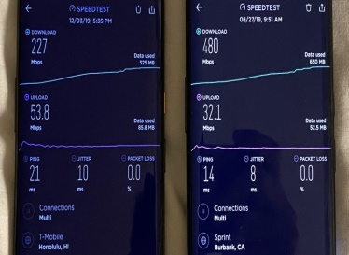 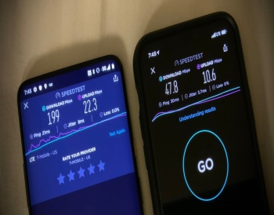 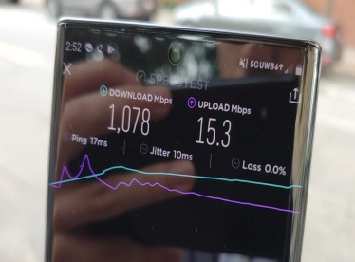

On this page, you can browse the news about the development of 5G.



Click here, you can edit the news about the development of 5G.



Click here, you can see other users' comments.



Click here, you can add a comment about the development of 5G.

.

### 5G Market

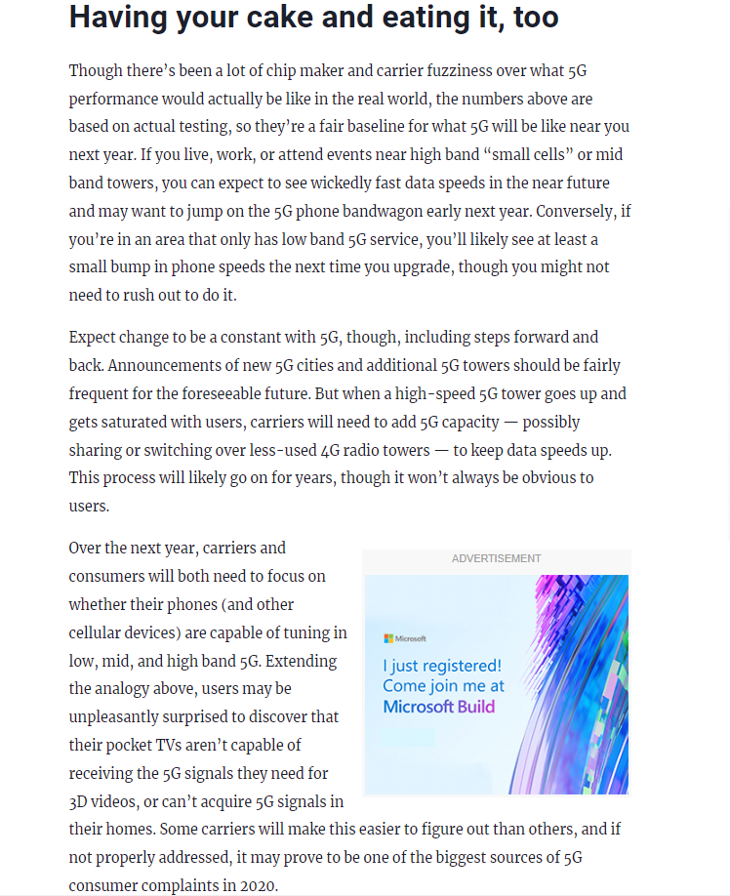

We will briefly describe how to edit a WIKI on this page



Click here, you can edit the user guide.



Click here, you can see other users' comments.



Click here, you can add a comment about user guide.

# III: About our team

Leader: Fang Sen

Our team is a modest and studious team. If you are also interested in 5G technology, please join us. In addition, if you find any editing errors on our wiki, please contact us in time!

Contact us: z18235136582@icloud.com